**South Park Season 24 Episode 2: Release and other details!** 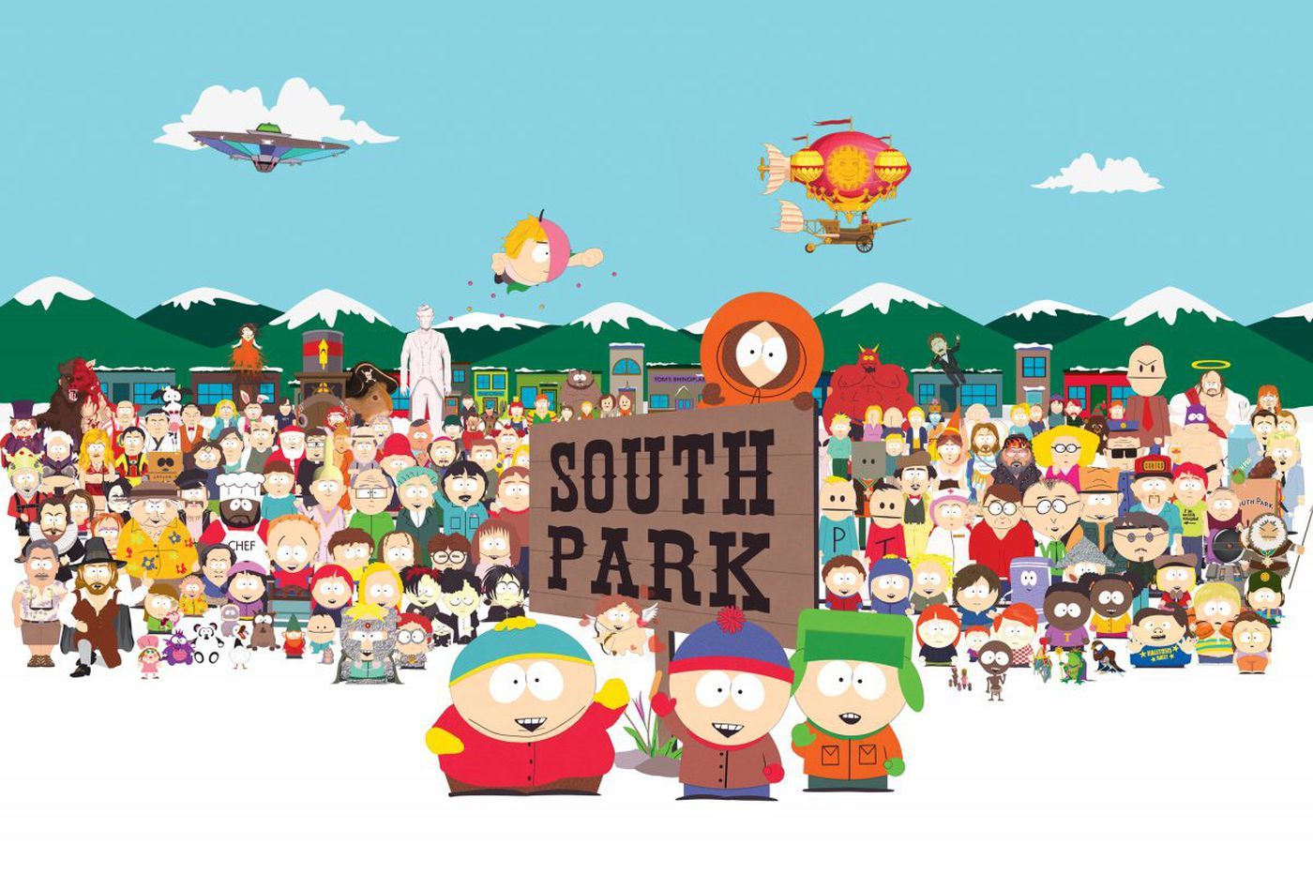

**South Park**, an American a*nimated* television *series* which has been streaming since August 13, 1997. It has been created by Trey Parker and Matt Stone and developed by Brian Graden for Comedy Central. It’s one of the greatest animated-series of all the time. So, it’s quite usual that it has a huge fan base waiting for its 24th season episode 2, since episode 1 has been on the viewers screen on September 30th, 2020.

**South Park Season 24 Episode 2: Cast and Plot**

It revolves around the story of four kids *Stan Marsh, Kyle Broflosvki, Eric Cartman*, and *Kenny McCormick* who live in *South Park*, an imaginative town located within the real-life South Park Basin in the Rocky Mountains of central Colorado. 

The *animated series* has already been renewed for 26 seasons, so **episode 2 of season 24** is quite assured to be released soon. Pandemic special was the name given to Episode 1 of *season 24* and according to the media sources it was named so as to picture the ongoing pandemic situation all over the world.

So, we can anticipate that the upcoming episodes will also cover up the common topics occurring especially in the US or worldwide like the prez elections which was a heated topic in the US politics. So, it won’t be wrong to say that *episode 2* will have some practical story.

**South Park Season 24 Episode 2: Release Date**

Since, the *episode 1 of season 24* was broadcasted on September 30, 2020. So, it’s highly likely that **season 2** will release by mid of 2021. We’re anticipating the *release date* because there’s no information from the creator side about the same.

There’s no *release* of the **trailer** of the *season 2* too. Till that time, you can enjoy the *trailer* of the Pandemic Special *episode* i.e., *episode* 1 of *season 24* 😊

https://www.youtube.com/watch?v=tsD0CNTDKQA